
Astana IT University

Introduction to Threat Hunting

week 10
Learning APT techniques

Students:
Aruzhan Abdulina, Kanasheva Darina

Instructor:

Tendikov Noyan

Submission Date: 29.10.2026
APT (Advanced Persistent Threat) is not a one-off attack but a long-running, well-organized campaign, usually run by a state-sponsored or highly professional group — “persistent” means the attackers do not simply get in and leave, but can remain inside a victim's network undetected for years. The task is to take a publicly documented profile of such a group (from Mandiant/CrowdStrike reporting) and reproduce its characteristic techniques in the lab, in order to check what is and is not visible in the SIEM. This is a direct continuation of Weeks 8–9: there a plan was built and tested using ready-made atomic tests; here the same approach is applied to a specific, real, major APT group rather than only to Storm-0501.
APT29 (Cozy Bear / Nobelium) was selected — a state-sponsored group known from Mandiant and CrowdStrike reporting for hidden command execution, registry-based persistence, and credential dumping from the LSASS process. Based on public descriptions of this group's TTPs, three techniques were chosen for practical emulation on the lab stand (Windows 11 VM, Sysmon, Splunk, configured in Weeks 5–9):
- T1059.001 — Command and Scripting Interpreter: PowerShell (hidden execution of an encoded command).
- T1547.001 — Boot or Logon Autostart Execution: Registry Run Keys (persistence via the registry).
- T1003.001 — OS Credential Dumping: LSASS Memory (dumping the LSASS process memory).

Technique Emulation

T1059.001 — Hidden Execution of an Encoded Command
A technique characteristic of APT29 was emulated: launching PowerShell with a hidden window and the -EncodedCommand argument (Base64), which makes command-line analysis harder without first decoding it.
Fig. 1. Execution of powershell.exe -nop -w hidden -enc <Base64> — a classic obfuscation pattern used by APT groups to hide the real payload from surface-level log analysis.

T1547.001 — Persistence via Registry Autorun Key
Creation of an autorun key under HKEY_CURRENT_USER was emulated, pointing to a safe test executable (calc.exe instead of a real malicious payload).
Fig. 2. The command reg add "HKEY_CURRENT_USER\Software\Microsoft\Windows\CurrentVersion\Run" /v "APT29_Test" /t REG_SZ /d "C:\Windows\System32\calc.exe" /f completed successfully (“The operation completed successfully”).

T1003.001 — Attempted Access to LSASS Memory
A series of Invoke-AtomicTest T1003.001 sub-tests was run, covering several LSASS-dumping methods (ProcDump, comsvcs.dll, NanoDump, the built-in Mimikatz, and others).
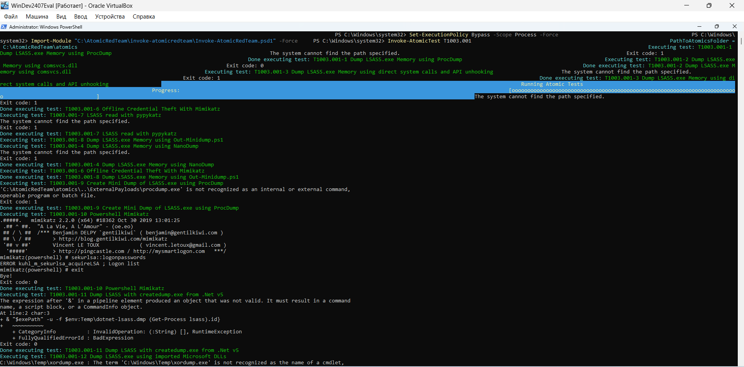
Fig. 3. Most sub-tests (ProcDump, comsvcs.dll, NanoDump, Out-Minidump, ProcDump mini-dump) failed with “The system cannot find the path specified”, since the external utilities were not pre-staged in the isolated lab environment. Sub-test T1003.001-10 (Powershell Mimikatz) launched a bundled copy of Mimikatz 2.2.0, which printed its banner and attempted sekurlsa::logonpasswords, but returned the error ERROR kuhl_m_sekurlsa_acquireLSA — meaning the attempt to access LSASS memory did occur, but no credentials were actually extracted.
Important clarification: although several sub-tests failed outright, the attempt to access the lsass.exe process itself did occur at the OS level — this is exactly what the next section checks: whether the SIEM sees the access attempt itself, regardless of whether it ultimately succeeded.

Splunk Validation and Visibility Analysis

T1059.001 — Execution: Detected
index=main source="WinEventLog:Microsoft-Windows-Sysmon/Operational" EventCode=1 Image="*powershell.exe" NOT Image="*splunk*" | table _time User Image CommandLine | sort _time
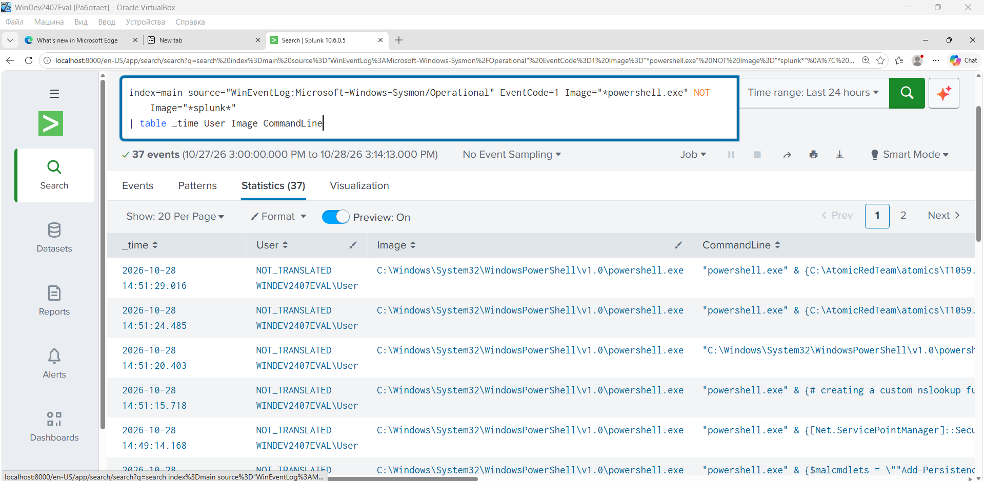
Fig. 4. The query returned 37 events. The CommandLine field shows invocations of the atomic tests (C:\AtomicRedTeam\atomics\T1059...), confirming full visibility of PowerShell command execution under the current Sysmon configuration.

T1003.001 — Credential Access: Not Detected (Visibility Gap)
index=main source="WinEventLog:Microsoft-Windows-Sysmon/Operational" EventCode=10 TargetImage="*lsass.exe*" | table _time SourceImage TargetImage GrantedAccess
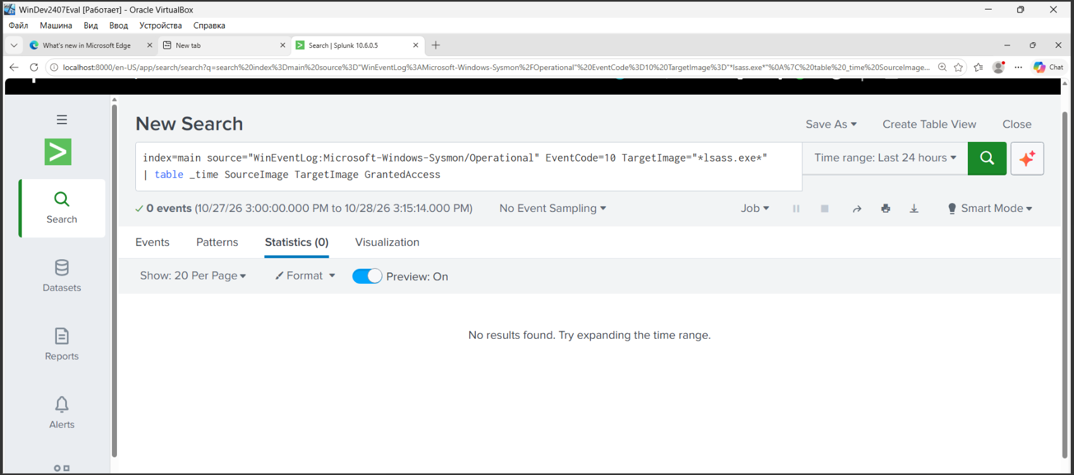
Fig. 5. The query returned 0 events. Despite the documented attempt to access lsass.exe in Section 2.3 (Invoke-AtomicTest T1003.001-10), no ProcessAccess event (EventCode 10) appears in the logs — the process-access monitoring rule is not enabled in the current Sysmon configuration.

T1547.001 — Persistence: Not Detected (Visibility Gap)
index=main source="WinEventLog:Microsoft-Windows-Sysmon/Operational" (EventCode=12 OR EventCode=13) | table _time User TargetObject Details
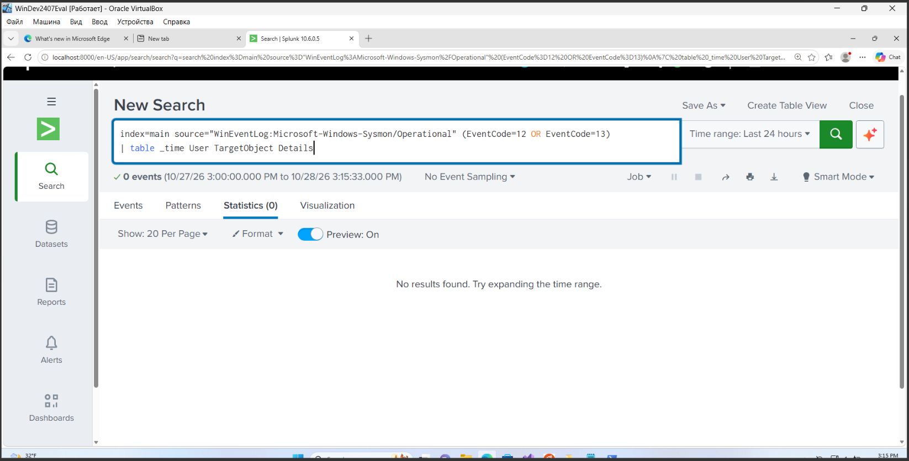
Fig. 6. The query returned 0 events. Even though the APT29_Test registry key was successfully created at the OS level (Section 2.2), no RegistryEvent (EventCode 12/13) appears in the Sysmon logs — the registry-monitoring rule is not configured.

Summary Mapping Table and Detection Status
Tactic | Technique | Procedure (what was emulated) | Result in Sysmon/Splunk | Takeaway
Execution | T1059.001 | Running PowerShell with a hidden window and a Base64-encoded command (-nop -w hidden -enc ...), plus Invoke-AtomicTest atomic tests. | Detected — EventCode 1, 37 events after filtering out Splunk noise | Full visibility into command execution
Persistence | T1547.001 | Creating the autorun registry key APT29_Test under HKCU\...\CurrentVersion\Run, pointing to calc.exe (a safe test target). | Missed — EventCode 12/13 returned 0 events | Blind spot: registry events are not logged by the current Sysmon configuration
Credential Access | T1003.001 | Attempted access to lsass.exe memory via Invoke-AtomicTest T1003.001 (built-in Mimikatz, ProcDump, comsvcs.dll, and other sub-tests). | Missed — EventCode 10 (TargetImage=lsass.exe) returned 0 events | Blind spot: the ProcessAccess rule is not configured in Sysmon

Conclusions and SIEM Tuning Recommendations
- The APT29 profile was confirmed in practice: the group combines hidden script execution (T1059.001), registry-based persistence (T1547.001), and credential-dumping attempts (T1003.001) — all three techniques were successfully reproduced on the lab stand.
- The main analytical finding is a Visibility Gap: the execution technique (T1059.001) is fully visible in the SIEM, while persistence (T1547.001) and LSASS access (T1003.001) go unnoticed under the current Sysmon configuration, even though the underlying OS-level actions did take place.
- Sysmon tuning recommendation: add a RegistryEvent rule for the ...CurrentVersion\Run key paths (covering EventCode 12/13) and a ProcessAccess rule protecting lsass.exe (covering EventCode 10) to the Sysmon configuration XML.
- Splunk correlation recommendation: create an Alert rule that fires when two conditions are met within a short window (for example, 5 minutes) — creation of a powershell.exe process with the -w hidden flag, followed by access to the registry or to lsass.exe memory.
This exercise demonstrates a classic SOC-analyst takeaway: a successful attack emulation does not by itself guarantee detection — telemetry completeness (visibility) must be checked separately for each technique, not only for the ones that are detected “out of the box.”

